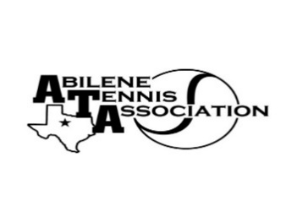
Abilene Tennis Association Board Meeting Minutes

- Location – Abilene Country Club, South
- Date & Time – 9/22/25 6:45pm

Board Members present:
- Jennifer Smothermon
- Rick Meyers
- Rich Bryan
- Benny Morentin
- Doug Mauldin
- Mindy Bible
- Beverly Guthrie
Board Members unable to attend: Leila Darby, Nancy Willis
New Business

- The meeting was called to order at 6:30 pm
- The Board discussed UTR tournaments and whether to host verified tournaments in the fall. They determined to offer verified tournaments through the end of 2025.
- The Board discussed potential dates for UTR tournaments in 2026.
- The Board discussed Coaches’ grants; agreed to remind coaches to apply by the deadline.
- The Board discussed and approved $250 for the congratulatory ad for the Texas Tennis Hall of Fame.
- Nominations for New Board Members: Rose Bristow, Kevin Crousen, Karla McCall, Jamie Clawsen (Catherine Wilson and Randy Ivey as Alternate nominees). Rick will reach out to Rebecca Strauser, and Benny will reach out to Ann Carr to see if either will represent AHS. Beverly made a motion to approve Karla, Rose, Kevin, and Jamie for the Board; Rick seconded the motion; all approved.

Minutes from past meeting – review, update and approve

The Board reviewed the minutes. Beverly made a motion to approve the minutes; Rick seconded. The minutes were approved by the Board.

Treasurer’s Report
- Mindy presented the Treasure’s Reports for August and September.
- Beverly made a motion to approve the financials; Benny seconded the motion. The Board voted to approve the report.

Committee Updates –
- Fundraising: (Beverly and Mindy) Current Sponsorships - $19,400.00.
- Junior Tennis Committee: (Jennifer, Leila, Marilyn & Nancy) Chris Causer will run fall JTT; the Board will need to find someone to run JTT in the spring/future.
- Community Tennis Development and Marketing – (Beverly, Chairman, Benny, & Rick) Jake is updating the website. Rich asked the Board to report if there are issues with registration or other website issues.
- Financial and Operations/Administration Committee: (Mindy, Jennifer & Benny) no report
- Adult Tennis Committee: (Doug) The Board discussed who would might be in charge of Women’s tennis and Men’s tennis.
- Officials and Referees Committee: (Rich & Benny) no report
- Schools Committee: (Rich) -Coaches will be reminded to apply for their grants
- Tournaments: (Rich) no report
- Banquet Committee: (Jennifer, Leila, Nancy) no report

Beverly made a motion to adjourn at 7:38 pm; Benny seconded.

Announcements:

Next Board meeting will be on Monday, October 20th at 6:30 pm at ACC South Pavilion

Prepared by: Jennifer Smothermon, ATA Secretary

