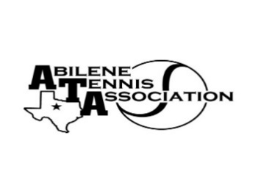
Abilene Tennis Association Board Meeting Minutes

- Location – Abilene Country Club
- Date & Time – 2/19/25 6:30pm

Board Members present:
- Jennifer Smothermon
- Beverly Guthrie
- Rich Bryan
- Benny Morentin
- Mindy Bible
- Doug Mauldin
Board Members unable to attend: Rick Meyers, Marilyn Crowe, Leila Darby, Nancy Willis
Visitors: None
New Business

- The meeting was called to order at 6:40
- The Board discussed the JTT Scholarship Application and approved.
- Discussed Adult League Coordinator – will table the discussion to a future meeting.

Minutes from past meeting – review, update and approve

January Minutes were reviewed. Beverly made a motion to approve; Rich seconded. The minutes were approved by the Board.

Treasurer’s Report
- Mindy presented the Treasurer’s Report.
- Benny made a motion to approve the report; Beverly seconded. The Board approved the report.
- Mindy updated information for signers for the bank.

Committee Updates –
- Fundraising: Beverly and Mindy. Discussed current sponsorship lists and those that are still outstanding. The Board will need to raise approximately $20K in sponsorships to support expenses in 2025.
- Junior Tennis Committee: Jennifer, Leila, Marilyn & Nancy Willis. JTT flyers have gone out and scholarship applications will be distributed through the coaches.
- Community Tennis Development and Marketing – Beverly, Chairman, Benny, & Rick Meyers. Jake is updating the website. Rich asked the Board to report if there are issues with registration or other website issues.
- Financial and Operations/Administration Committee: Mindy, Jennifer & Benny: no report
- Adult Tennis Committee: Doug, Chairman, Jennifer Nevajas, Valerie, Jill, Samuel; Adult Mixer will be held at Abilene Country Club North in May (postponed from March to May). ATA will provide prizes for participants.
- Officials and Referees Committee – Rich & Benny. Rich reported that officials are lined up for upcoming tournaments; at this point, they are happy with the reimbursement rate.
- Schools Committee: Rich - no report
- Tournaments: Rich – UTR this weekend; shortage on officials for this tournament; Rich agreed to be onsite to help fill in.
- Banquet Committee: Discussed the Passion for Tennis Award application; table to next meeting. AHS 4/29/25 (Leila Darby), CHS 5/5/25 (Jennifer Smothermon), WHS 5/13/25 (Nancy Willis), all at Oldham Lane Church of Christ.

Benny made a motion to adjourn at 7:15pm; Mindy seconded.

Announcements:

Next Board meeting will be on Monday, March 17th at 7:00pm at Abilene Country Club Tennis Pro Shop.

Prepared by: Jennifer Smothermon, ATA Secretary

