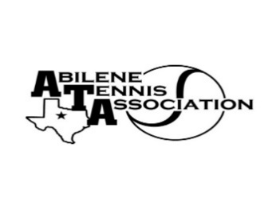
Abilene Tennis Association Board Meeting Minutes

- Location – Home of Beverly Guthrie
- Date & Time – 9/3/24 at 7:00pm

Board Members present:
- Jennifer Smothermon
- Mindy Bible
- Beverly Guthrie
- Rich Bryan
- Nancy Willis
- Leila Darby
- Marilyn Crowe
- Doug Mauldin
- Leila Darby
- Rick Meyers
- Benny Morenin by phone
Board Members unable to attend: none
Visitors: None
New Business

- Rich called the meeting to order at 7:25pm.
- Board discussed the shift from USTA/JTT to UTR Juniors Team Tennis (see committee report).
- Discussed verified vs. non-verified UTRs, costs and benefits, specifically to the Abilene community.
- Discussed tennis ball shipment from Wilson.

Minutes from past meeting – review, update and approve

June Board Meeting Minutes were reviewed and approved with changes. July Board Meeting Minutes were reviewed and approved with changes.

Treasurer’s Report
- Mindy presented the Treasurer’s Report for July and August. Beverly motioned to accept the report, and Rick seconded; motion passed.

Committee Updates –
- Fundraising - $21,140.00 raised in the spring.
- Junior Tennis Committee: Jennifer, Leila, Marilyn & Nancy Willis. Beverly reported on UTR Team Tennis. Beverly and Benny will plan a conference call with Nick to explore this option. Discussed approaching Josh Lopez to run the program. Discussed starting in the fall or spring.
- Community Tennis Development and Marketing – Beverly, Chairman, Benny, & Rick Meyers
- Financial and Operations/Administration Committee: Mindy, Jennifer & Benny
- Adult Tennis Committee: Doug, Chairman, Jennifer Nevajas, Valerie, Jill, Samuel; Discussed Adult Mixer for the fall. Budgeted $1000 + entry fee of $15 per person. Benny will reach out to ACC to make arrangements.
- Officials and Referees Committee – Rich & Benny. Discussed officials’ reimbursement.
- Schools Committee: Rich
- Tournaments: Fall UTR dates: September 14-15, October 19-20, November 9-10 for WHS; December 14-15; make sure that the behavior contract is on the website for every player/parent to sign when they register for UTR. Verified that Tiffany Nichols from the City of Abilene bid on Mixed 18 Sectionals and the Mixed 55 Sectionals for years 2025-2027.
- Banquet Committee: no report

Rick made a motion to adjourn at 8:40 pm; Mindy seconded.

Announcements:

Next Board meeting will be Wednesday, October 9th or 16th, at 6:30 pm at ACC. Beverly will follow up.

Prepared by: Jennifer Smothermon, ATA Secretary

