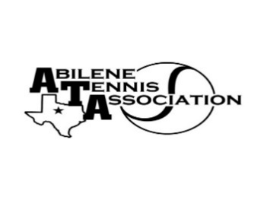
Abilene Tennis Association Board Meeting Minutes

- Location – Abilene Country Club, Oval Room

- Date & Time – 2/20/24 at 6:30pm

Board Members present:
- Jennifer Smothermon
- Benny Morentin
- Beverly Guthrie
- Rick Meyers
- Rich Bryan
Board Members unable to attend: Leila Darby, Doug Mauldin, Mindy Bible, Marilyn Crowe, Nancy Willis
Visitors: Ella Kate Smothermon
Business

- Benny called the meeting to order at 6:30 pm.
- The Board reviewed the list of sponsors from 2023 and signed and addressed letters along with sponsorship forms to be mailed or hand-delivered to sponsors. The Board decided to reach out to people registered in the Adult League to off opportunity to sponsor in the coming year.
- Benny gave a report from the USTA call.
    - Growth of USTA Texas programs
    - Possibility of hosting USTA Level 4 tournament in Abilene in the coming year
- The Board discussed the Adult League
    - The current registration fee is $29. The Board decided to do research to determine fees in other cities and discussed the possibility of increasing the fees to $35, to increase the amount that ATA would collect from $12 to $18 per registrant.
    - Beverly gave an update on registration and working with Melinda

Minutes from past meeting – review, update and approve

Minutes were not reviewed or approved due to the lack of a quorum.

Treasurer’s Report
- Mindy submitted the Treasurer’s Report via email.
- The Report was not reviewed or approved due to a lack of a quorum.

Committee Updates –
- Fundraising
- Annual Tennis Banquets:
- Sponsorship Drive: Beverly will send out sponsorship letters in Jan/Feb, and board members will follow up afterwards.
- Junior Tennis Committee: Jennifer, Chairman, Leila, Marilyn & Nancy Willis
- Community Tennis Development and Marketing – Beverly, Chairman, Benny, & Rick Meyers
- Financial and Operations/Adminstration Committee: Mindy, Jennifer & Benny
- Adult Tennis Committee: Doug, Chairman, Jennifer Nevajas, others (Valerie, Lydia, Jill?)
- Officials and Referees Committee – Rich & Benny
- Schools Committee: Rich

The meeting was adjourned at 7:30pm.
Announcements

A reception for Seniors and scholarships will be held in April at The Grace.

Next Board meeting will be Tuesday, March 19, 2024
(Need to approve Minutes from December and January meetings and Financials from January)

Prepared by: Jennifer Smothermon, Secretary

