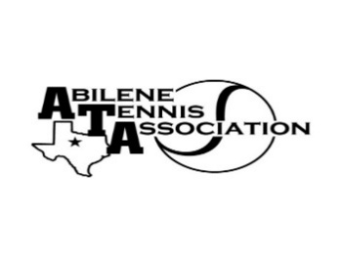
bilene Tennis Association Board Meeting Minutes

- Location – Abilene Country Club

- Date & Time – 10/24/2023 6:30pm

Board Members present:
- Reene Bontke
- Mindy Bible
- Beverly Guthrie
- Jennifer Smotherman
- Rick Meyers
- Jennifer Navejas
- Rich Bryan
- Nancy Willis
- Marilyn Crowe
Board Members unable to attend: Benny Morentin, Shannel Anderson, Leila Darby
Business

- Renee called the meeting to order at 6:30pm.
- Mindy Bible told the board that the scoreboard monies were being refunded
- The College Show Case that was supposed to be the first weekend of November was cancelled to lack of Coaches attending
- Rich Bryan has talked to all the various Coaches and is working on the Tournaments for the first half of 2024
- Discussion of the Adult League rules had been updated and how they had been posted on Website. Reene made a motion to approve and Jennifer Smotherman seconded, all approved.
- Discussion of the order of Tennis Balls for 2024 were to be downsized to 25 cases a quarter instead of 40. Beverly made a motion to approve, Reene seconded and all approved.
- The Board discussed the bid of the Texas Slam but felt like it was not something the ATA could take on at the moment.
- There was long discussion of Parent/Player Rules, it was decided that rules would be set up based on examples provided by Rich and what is used in the AISD middle schools. The Rules were finished and all approved them.

Minutes from past meeting – review, update and approve
The 8/15 minutes were approved by all after a motion by Reene and seconded by Nance. The 9/28/23 minutes were approved by all after a motion by Reene and seconded by Rich. All Approved

Treasurer’s Report
Mindy gave the Treasurer’s report. Reene made a motion to approve and Rick seconded, all approved.

Committee Updates
- Officials/Referees –
- Fundraising/Sponsorship
- Financial
- Banquet:
- Adult tennis: In September there were 289 players in the USTA Mixed Sectionals. ACVB paid for the player’s party. Todd from USTA seemed very happy. There will be an Adult Mixer at ACU, Bryan Rainwater is finding a date. Doug Mauldin has agreed to help Jennifer with the Adult League. Planning a party at the Mill in December, Plan B would be Fairway.
- Tournament Committee
- Junior Team Tennis: - JTT Sectionals at Newks on December 2nd
- Schools: N/A

Meeting adjourned at : 8:00 pm

Prepared by: Beverly Guthrie

