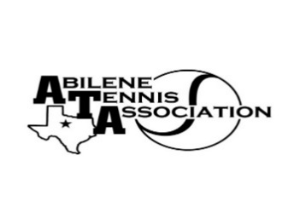
Abilene Tennis Association Board Meeting Minutes

- Location – Abilene Country Club

- Date & Time – 7/18/23 6:30pm

Board Members present:
- Nancy Willis
- Reene Bontke
- Leila Darby
- Benny Morentin
- Mindy Bible
- Beverly Guthrie
- Marilyn Crowe
- Jennifer Smothermon
- Rich Bryan
- Shannel Anderson
Board Members unable to attend: Jennifer Navejas and Rick Meyers
Others Present: None
Business

- Renee called the meeting to order at 6:30pm.
- The Board discussed the possibility of covered courts at Rose Park, Shannel Anderson updated the board of what is going on. The City has their own non-profit that they will run money through if it is approved.
- The Board discussed that the Sponsored funds for Wylie Score Boards ($6500). Will be returned to the 9 donors.
- The Board discussed giving each of the High Schools 5 cases of balls to start their season. Benny will have his employees pick those up and the coaches can pick up at the Country Club. Reene made the motion, Benny Seconded and all approved.
- Discussion about Wylie East using their grant for 10 cases of balls. Beverly will talk to Savannah about using her money for something else. The Country Club has a bunch of balls that they will be glad to give to the middle schools. Rich will coordinate with Benny to get those to the schools.
- Board discussed whether to have College Show Case on November 4-5, 2023. Beverly will talk to Chris Breaux. Shane Williford was not to excited about having it again.
- Adventure Cove refunded $350 since there was a storm and we were not able to hold the swimming the entire time.

Minutes from past meeting – review, update and approve

Minutes from April & June were reviewed. Jennifer Smothermon made a motion to approve, Benny Morentin seconded and all approved.

Treasurer’s Report
Mindy gave the Treasurer’s report for April, May, & June. Discussion of banquet and grant money needing to be moved around to update the report. Rich made a motion to approve the treasurer’s report, Mindy seconded and all approved.

Committee Updates
- Officials/Referees – Rich commented that the Official at the UTR was successful and we plan to have at the other to UTRs
- Fundraising/Sponsorship
- Financial
- Banquet:
- Adult tennis:
- Tournament Committee
- Junior Team Tennis:
- Schools: N/A
Renee made a motion to adjourn the meeting at 7:50 pm, and Jennifer seconded.
Announcements

August Board meeting will be Tuesday, August 15, 2023, at 6:30 at the Abilene Country Club

Prepared by: Beverly Guthrie

