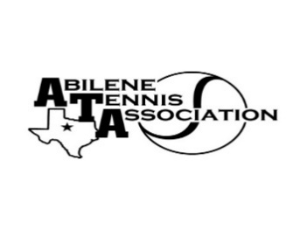
bilene Tennis Association Board Meeting Minutes

- Location – Abilene Country Club

- Date & Time – 12/12/2023 6:30pm

Board Members present:
- Reene Bontke
- Shannel Anderson
- Beverly Guthrie
- Jennifer Smotherman by phone
- Rick Meyers
- Benny Morentin
- Rich Bryan
- Leila Darby

Board Members unable to attend: Jennifer Navejas, Nancy Willis, Marilyn Crowe, Mindy Bible
Business

- Renee called the meeting to order at 6:30pm.
- The Board Discussed going ahead and setting the Banquet Allocations to the 3 High Schools. A motion was made by Reene to set at $2,500 again, Benny seconded the motion. All approved
- Tournament schedule was presented, at the time of the meeting we were waiting on Brent Abilez to send his schedule.
- Discussed the Parent/Player Rules at the last UTR and it seemed to have gone smoothly. We will continue to enforce those rules.
- We discussed meeting with USTA to meet the Executive Director of Texas on January 12th at 11:30 at the Abilene Country Club. Then they will host a reception in the 4039 Room from 4:30-6:30 for the board, and the invited tennis community, along with San Angelo, and Midland.
- Discussed the meeting for the Coaches in January. It will be on January 21st, Beverly will check with Lytle Land and Cattle and make reservations.
- Discussion of Board for 2024. Shannel Anderson will rotate off and so will Jennifer Navejas. It was suggested that Doug Mauldin be asked along with Randy Ivey to fill those two positions. That would bring the board back up to 12. Reene is willing to stay on a ExOfficio.
- The Board discussed having its budget meeting on January 14th at Beverly Guthrie’s House to discuss ball allocation, etc.
- Discussed the 55 & Over Mixed going to Nationals and voted to give the $1,000, Beverly made the motion and Reene seconded it. All approved.

Minutes from past meeting – review, update and approve
The 10/24 minutes were approved by all after a motion by Reene and seconded by Jennifer Smothermon. All Approved

Treasurer’s Report
Mindy was not available to give the Treasurer’s report, but will do so at our Budget Meeting on January 14th, 2024

Committee Updates
- Officials/Referees –
- Fundraising/Sponsorship
- Financial
- Banquet:
- Adult tennis:
- Tournament Committee
- Junior Team Tennis: -
- Schools: N/A

Meeting adjourned at : 8:00 pm

Prepared by: Beverly Guthrie

