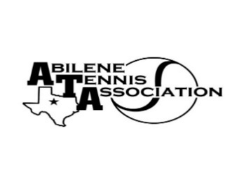
Abilene Tennis Association Board Meeting Minutes

- Location – Abilene Country Club

- Date & Time – 8/15/2023 6:30pm

Board Members present:
- Nancy Willis
- Reene Bontke
- Benny Morentin
- Mindy Bible
- Beverly Guthrie
- Shannel Anderson
- Rick Meyers
Board Members unable to attend: Jennifer Navejas, Rich Bryan, Jennifer Smothermon, Marilyn Crowe, Leila Darby,
Others Present: None
Business

- Renee called the meeting to order at 6:30pm.
- The Board discussed the possibility of covered courts at Rose Park, Shannel Anderson updated the board of what is going on.
- The Board discussed that the Sponsored funds for Wylie Score Boards ($6500). Will be returned to the 9 donors. This was confirmed and Mindy was going to write the check.
- The board discussed the College Showcase to be held as a UTR if Chris Breaux could get commitments from colleges. Rich Bryan was going to help. Minimum UTR’s can be set.
- Board voted to give $1,000 check for the 4.0 Women 18&Over Sectional Champions to go to Nationals.

Minutes from past meeting – review, update and approve

Minutes from July were reviewed. Reene Bontke made a motion to approve, Benny seconded and all approved.

Treasurer’s Report
Mindy gave the Treasurer’s report for July. Reene Bontke made a motion to approve and Rick seconded, all approved.

Committee Updates
- Officials/Referees –
- Fundraising/Sponsorship
- Financial
- Banquet:
- Adult tennis:
- Tournament Committee
- Junior Team Tennis:
- Schools: N/A
Renee made a motion to adjourn the meeting at 7:23 pm, and Rick seconded.
Announcements

August Board meeting will be Thursday, September 28th, at 6:30 at the Abilene Country Club

Prepared by: Beverly Guthrie

