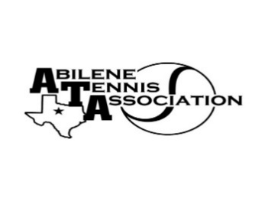
Abilene Tennis Association Board Meeting Minutes

- Location – Abilene Country Club

- Date & Time – 4/18/2023 6:30pm

Board Members present:
- Beverly Guthrie
- Nancy Willis
- Reene Bontke
- Leila Darby
- Mindy Bible
- Rick Meyers
- Jennifer Smothermon
- Shannel Anderson
- Rich Bryan
Board Members unable to attend: Marilyn Crowe, Benny Morentin, Jennifer Navejas
Others Present: None
Business

- Renee called the meeting to order at 6:30pm.
- The Board discussed Sponsorships again, and went over what had been received. We were ready to order Banners.
- The Board discussed the College Camps for the Banquet and drawings were done, WHS received the Texas Tech Camp, CHS received the HSU Camp and AHS received the A&M Camp. WHS received the Newks Camp. Each High School received a McMurry Camp for the junior highs
- Banquet updates were discussed
- Senior Reception was discussed and Renee discussed the Agenda Program
- Rich Bryan had fall UTR Dates, Beverly Guthrie made a motion to approve. Mindy Bible, seconded and all approved:
Dates are September 9/10, October 21/22 and December 2/3 This was done by GroupMe

Minutes from past meeting – review, update and approve

- Minutes from the March meeting were read, Beverly Guthrie made a motion to approve and Rick Meyers seconded, all approved.

Treasurer’s Report
- The Board went over February financials; Mindy gave the Treasurer’s Report. Jennifer Smothermon made a motion to accept the report; Rick seconded.

Committee Updates
- Officials/Referees:
- Fundraising/Sponsorship-
- Financial
- Banquet:
- Adult tennis – Mindy, Jennifer Navejas, Reene & Beverly, Melinda met April 17 for Adult League Committee. Discussion was made that Melinda would get reminders out regarding date deadlines, and set deadlines for Team Numbers. There will NOT be further extensions or late registrations.
- Tournament Committee –.
- Junior
- Schools: N/A
Renee made a motion to adjourn the meeting at 7:41 pm, and Beverly seconded.
Announcements

May Board meeting will be Tuesday, May 18th, at 6:30 at the Abilene Country Club

Prepared by: Beverly Guthrie

