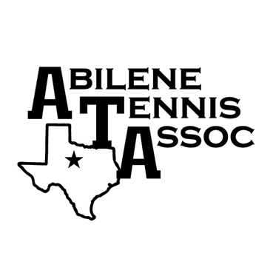
JTT Spring 2024

Sectionals is May 18-19
(Sectional fees $ 215.00 will be paid by the team)

10U Green Ball (ages 9 & 10) - Sundays 2 pm at Rose Park

12U Green Ball (ages 11 & 12) - Sundays 2 pm at Rose Park

12U & 14U matches - Sundays 4 pm at Rose Park

18U matches - Sundays 2 pm at McMurry

Match Dates 2/25 – 4/21

Registration cost is $ 50.00 per player plus TennisLink fee
Registration ends on 2/15/24 – register online at abilenetennis.org
click on JTT registration button
10U & 12U Green ball – use 10U - 12U Green Ball button
12U – 18U divisions use Yellow Ball button

Age cutoff is 5/31/24

Schedules will be posted on 2/24/24 on the website – www.abilenetennis.org

Reminders for Spring 2024
All players must have a USTA membership – can obtain online or call 1-800-990-8782
Teams may be any combination of boys and girls, except for 18U, 18U must have 1 girl.
A minimum of 4 (four) players per team is required for every division.
For 12U – 18U - Register in the division using WTN rating – More information on abilenetennis.org
Parents must stay with their players that are 12 and under
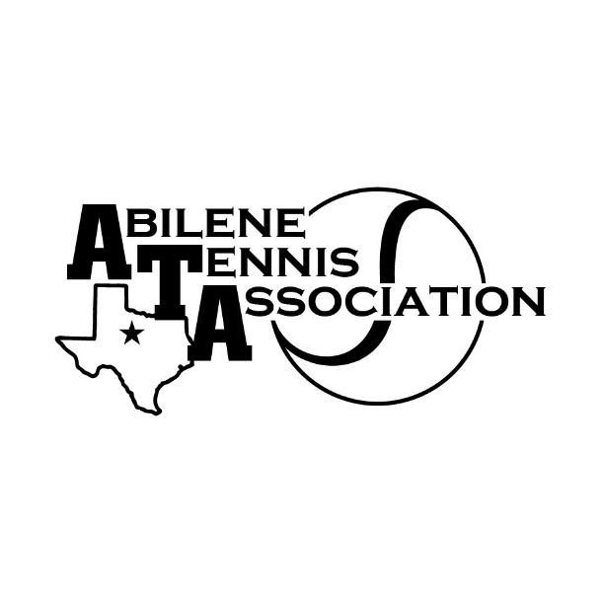
JTT Spring 2024 Non-Sectional
Red Ball & Orange Ball & Green Ball for Non-Sectional players

10&under must register based on ball color on Net Generation or if new player by ages specified
Red Ball (ages under 7) - Sundays at 3 pm on Court 1
Orange Ball (ages 7-9) – Sundays at 2 pm on Courts 12-13
Green Ball for Non-Sectional players (ages 9-12) – Sundays at 2 pm on Courts 14-15
5 Match Dates – starting 3/3 – ending 4/21 at Rose Park
Registration for Red is $25.00
Registration for Orange & Green Non-Sectional players is $ 30.00

Registration for Red & Orange & Green Non-Sectional players ends 2/29/24
For all registration, go to www.abilenetennis.org – click on JTT registration button
Red & Orange & Green Non-sectional players use buttons - Red or Orange or Green Non-Sectionals

For more information check website – abilenetennis.org or text Melinda Roberson 325-669-3340

We need parent volunteers – if you can volunteer, please text Melinda 325-669-3340

Parents must stay with their players that are 12 and under

