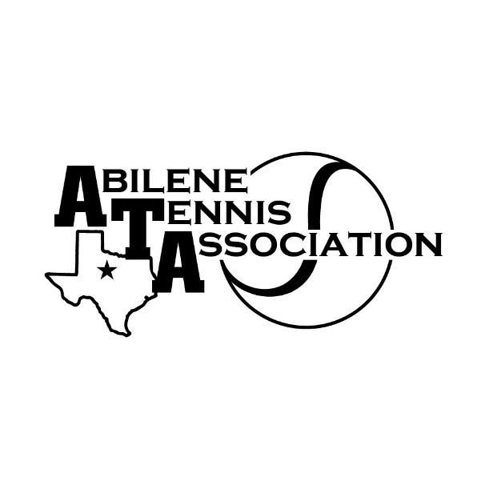
JTT Spring 2024 Non-Sectional
Red Ball & Orange Ball & Green Ball for Non-Sectional players

10&under must register based on ball color on Net Generation or if new player by ages specified
Red Ball (ages under 7) - Sundays at 3 pm on Court 1
Orange Ball (ages 7-9) – Sundays at 2 pm on Courts 12-13
Green Ball for Non-Sectional players (ages 9-12) – Sundays at 2 pm on Courts 14-15
5 Match Dates – starting 3/3 – ending 4/21 at Rose Park
Registration for Red is $25.00
Registration for Orange & Green Non-Sectional players is $ 30.00

Registration for Red & Orange & Green Non-Sectional players ends 2/29/24
For all registration, go to www.abilenetennis.org – click on JTT registration button
Red & Orange & Green Non-sectional players use buttons - Red or Orange or Green Non-Sectionals

For more information check website – abilenetennis.org or text Melinda Roberson 325-669-3340

We need parent volunteers – if you can volunteer, please text Melinda 325-669-3340

Parents must stay with their players that are 12 and under

