Abilene Adult League Rules & Procedures 2024

Table of Contents
Format for Local League play 2
Captain Responsibilities 2
Player’s Responsibilities 3
Determining Nationals Participation 3
Grievances 3
Waiver of Claims 4
Injuries 4

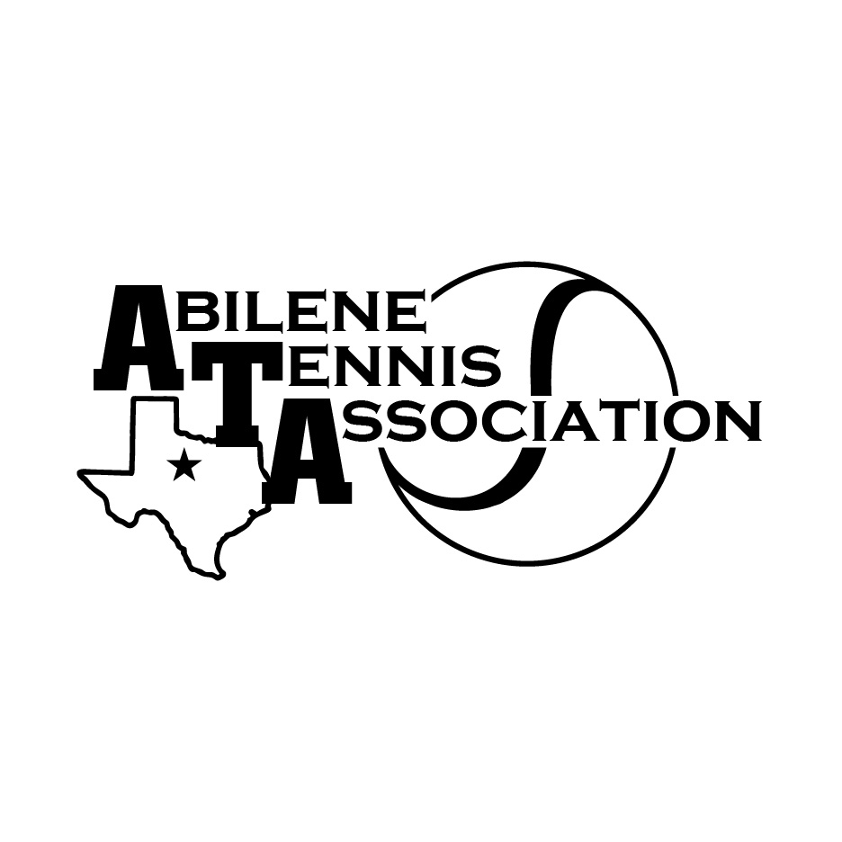
ATA will follow USTA and USTA Texas Regulations except for the following exceptions:

Format for Local League play

During local play teams will be using a FLEX schedule that will allow matches to be played on different days to avoid using defaults as a completed match. Matches that are scheduled between the captains must be ALL completed prior to beginning the next scheduled team match.

Matches are allowed to be played on separate dates, but only under extenuating circumstances can another team match begin prior to the completion of the unfinished match. All team matches must be completed in a week’s time (7 days) to remain on schedule for the remaining scheduled team matches. There are exceptions that can cause a delay in completion of matches (injury, illness, weather, family emergency, etc..) that must be agreed upon by both captains.

  - Teams can add up to two players at any time after the first scheduled match. Remember players must have played at least two matches (3 matches if they are self-rated or appealed) locally to qualify for Sectionals. The deadline to add players is before the last two or three scheduled matches depending on the players rating type. In some divisions only one match is required for all players so the deadline would be before the last match.
  - Teams may also request additional matches to add players to their roster dependent on certain circumstances (i.e., illness, injuries, family emergency) and must be approved by the ATA. The opposing captain must take into consideration the need for adding additional players and must be willing to help accommodate the additional matches.
  - The additional matches do not affect the outcome of the winning team. The additional matches are for championship eligibility.

Captain Responsibilities

Captains must request their team number and sign their team up by the designated deadlines. Teams that do not meet the scheduled deadline and wish to play in the local league will be subject to a penalty paid to the ATA to register. Dates for the local, sectional, and national levels of play are administered at the beginning of the calendar year and will be posted on the ATA website.

Guidelines for requesting an extension for registration:

  - The team must request the extension in writing and delivered to ATA within a week past the deadline.
  - The team must pay ATA $100 non-refundable fee for the penalty.
  - If the extension is granted the team will have 48 hours to get the team registered.
  - If matches in that division have already started the extension will be denied.
  - If team/players register to play matches and not competing for sectionals, they can register past the deadline without requesting an extension or receiving a penalty.
  - Both captains must sign the scorecard at the end of all matches.

*Both captains to set a date so that at least 2 lines be played. The remaining lines must be played before the next match. Line-up exchanged on set day.
**Captains have to show up for Captains meeting to be able to progress to sectionals

Player’s Responsibilities

- Expect players to follow the rules of the facilities that they are playing at.
- Expect players to follow the USTA Code of Conduct- remembering that when playing in an adult league you are representing Abilene Adult Tennis Leagues.
- Expect players to know the rules of tennis and wear the proper attire to play a tennis match.
- Expect players to follow USTA, USTA Texas, and local regulations.

Determining Nationals Participation

To receive any monetary help from the ATA the team’s roster must be 80% composed of local players of the Abilene area and within a 60-mile radius.

Grievances

Any grievance that comes up should be filed in writing and delivered to the ATA within 48 hours of the disputed match. Include a $50 grievance fee (non-refundable). A duplicate copy of the grievance will be sent to the opposing captain. The grievance committee on the ATA board will review and decide the issue in question.

Waiver of Claims

Players participating in the USTA League acknowledge the risks associated with playing competitive tennis, accept those risks voluntarily, and in consideration of their acceptance in the USTA League Program, assume all risks for bodily injury, waive all claims for injury and property damage and release and hold harmless to the USTA and the host facility, their officials, employees and agents with respect to any injury or loss caused by negligence or otherwise to the fullest extent permitted by law.

Injuries

Players are subject to play at their own risk following any injury. Players may also be allowed to play in necessary medical devices (i.e., knee braces, ankle braces, boot, cast, etc..) and is subject for fair play knowing the risks involved in playing with those devices. Please see the retirement guidelines as noted in the USTA Texas League Regulation.

These rules are subject to change based on USTA and USTA Texas regulations.

WE ARE TEAM ABILENE!!!

