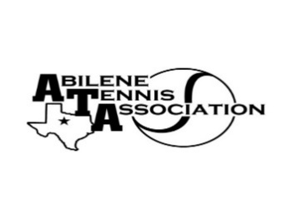**Abilene Tennis Association Board Meeting Notes**

* Location – Abilene Country Club Fireside Room
* Date & Time – 09/13/2022 6:15 pm

Board Members present:

* Beverly Guthrie
* Rick Meyers
* Marilyn Crowe
* Benny Morentin
* Reene Bontke
* Nancy Willis
* Mindy Bible

Board Members unable to attend: Jennifer Navejas, Shannel Anderson, Rich Bryan

Others Present: Susan Bowles

**Business**

1. Susan Bowles is starting Lone Star back up
2. Rick still hasn’t heard anything from the Hall of Fame that will be on November 5

**Minutes from past meeting – review, update and approve**

1. Minutes for August were read, and voted on. Reene made a motion and Benny seconded and all in favor.

**Treasurer’s Report**

1. The Board went over September’s financials, Reene made a motion to approve and Marilyn seconded and all approved.

**Committee Updates**

* Officials/Referees: none
* Fundraising/Sponsorship- NA
* Financial: N/A
* Banquet:
* **Adult tennis – Jennifer Navejas**
* Jennifer is having Tiffani Nichols find out about the 2nd weekend of November for a Level 5 Adult Tournament. Talked to Chris and they got is approved and sanctioned through USTA.
* **Tournament Committee – Beverly Guthrie**
* Talked about last USTA Level 6 and getting ready for the Fall UTRs
* Junior Tennis – no other updated
* Schools: N/A

Meeting adjourned 7:15 pm.

**Announcements**

Next Board meeting is November 1, 2022 at 6:15 in the Wine Room

**Prepared by:** Beverly Guthrie (October 15, 2022)