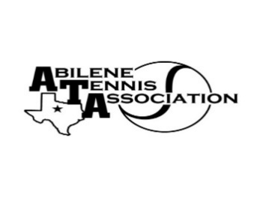
Abilene Tennis Association Board Meeting Notes

- Location – Abilene Country Club Wine Room

- Date & Time – 11/01/2022 6:15 pm

Board Members present:
- Beverly Guthrie
- Marilyn Crowe
- Benny Morentin
- Reene Bontke
- Nancy Willis
- Mindy Bible
- Jennifer Smotherman
- Leila Darby
- Shannel Anderson
Board Members unable to attend: Jennifer Navejas, Rick Meyers, Rich Bryan
Others Present:
Business

Talked about College Show Case

Minutes from past meeting – review, update and approve

- Minutes for September were read, and voted on. All in favor.

Treasurer’s Report
- The Board went over October’s financials, All approved.

Committee Updates
- Officials/Referees: none
- Fundraising/Sponsorship- NA
- Financial: N/A
- Banquet:
- Adult tennis – Jennifer Navejas
- .
- Tournament Committee – Beverly Guthrie
- Junior Tennis – no other updated
- Schools: N/A

Meeting adjourned 7:15 pm.
Announcements

Next Board meeting is November 1, 2022 at 6:15 in the Wine Room

Prepared by: Beverly Guthrie (October 15, 2022)

